**Quick Start Guide**

**Fore note:**

This guide is intended to help you set up the sample project as quickly as possible. For the quick start to work, you will need the December 2010 version of UDK, as we just copy over the entire folder.

I am targeting only the December 2010 version at the moment because the engines .ini files frequently change between versions of UDK and we will be copying an .ini file over the top of another. You can try this quick start on other version’s of UDK but I cannot guarantee that it won’t break it, so do so at your own risk.

You will need nFringe and Microsoft visual studio to start the project. I will add steps to start it in front end in the future.

**Step 1:**

The first thing that you will need to do is install the Kinect Sensor, OpenNI and NITE binaries.

Make sure that your Kinect is unplugged from your computer before you begin this step.

Open the folder called “**Installers**” found in the download. This will have a subfolder titled “**KinectInstall**” which contains a several files. The one that we are interested in is called “**KinectInstall.exe**”, which is a small program that automates the setup process for OpenNI / NITE / Kinect. Credit for this goes to:

<http://babaandthepigman.wordpress.com/2011/01/26/openni-kinect-getting-set-up-on-windows/>

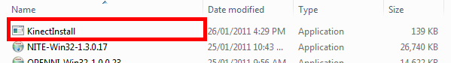

When you run this a small console window should appear and begin installing the OpenNI, NITE and Kinect Driver in the correct order. When this is finished, you can plug your Kinect back into your computer and move on.

**Step 2:**

In the folder this file was found in (**Quick Start**) there should be another folder titled **UDK-2010-12**.

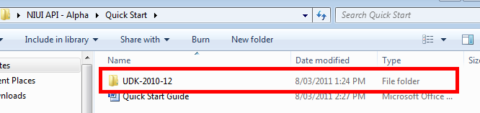

This contains all the files setup in the appropriate directories to allow you to simply copy it over your existing **UDK-2010-12** folder.

**Step 3:**

Copy the **UDK-2010-12** folder and browse to your UDK install directory. Paste the folder over your existing UDK-2010-12 folder.

When asked if you want to copy and replace the existing files, say yes. See below:

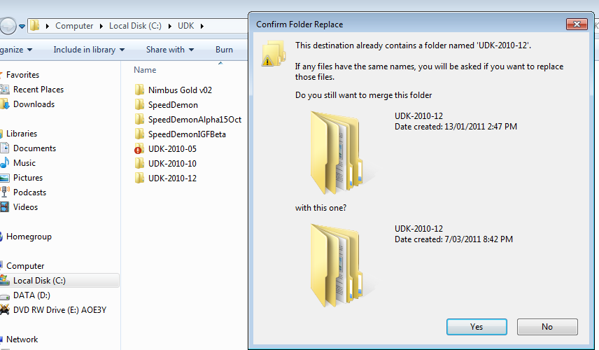

This will add the NIUI.dll, NIUIConfig.xml, the required OpenNI dlls, NIUI content packages, NIUI source code and also setup the UDKEngine.ini file to compile the sample project.

You should now be able to run the project by opening the NIUI project file that is within the UDK-2010-12/Development/Src/NIUI folder and pressing F5 to compile and run.